VirtualBox & Fedora on Windows Setup

The motivation is to install a Linux OS on a Windows machine. There are several options:

* cygwin: <https://www.cygwin.com/>
* MobaXterm: <http://mobaxterm.mobatek.net/>
* <http://unxutils.sourceforge.net/>

These are not full size Linux OS and so from time to time we run into incompatible issues. Another option is from PC virtualization:

* VirtualBox: <https://www.virtualbox.org/>
* VMWare Player: <https://www.vmware.com/products/player>
* MS Virtual PC: <https://www.microsoft.com/en-us/download/details.aspx?id=4580>

With these tools we could install full Linux OS in the virtual machine.

In this document, we will use VirtualBox.

Download VirtualBox & Extension package:

<http://www.oracle.com/technetwork/server-storage/virtualbox/downloads/index.html>

Then download the “Guest Additions” package from:

<https://www.virtualbox.org/wiki/Downloads>

This is needed for shared folders, clipboard, and screen size adjustment.

Download Fedora ISO image (We use the 64-bit workstation version) from:

<https://getfedora.org/en/>

So we have the following:

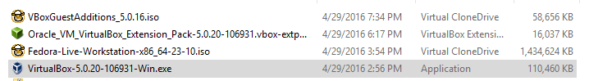

After installation of VirtualBox, turn off antivirus before installing Extension package. Otherwise we get the error saying can’t rename directory. Once these two are installed, we could set up a new virtual machine:

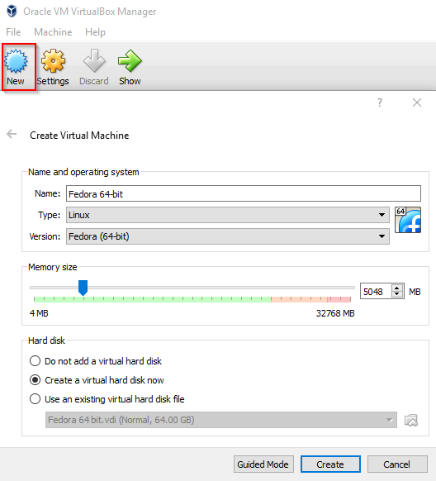

Most of the time we accept the defaults:

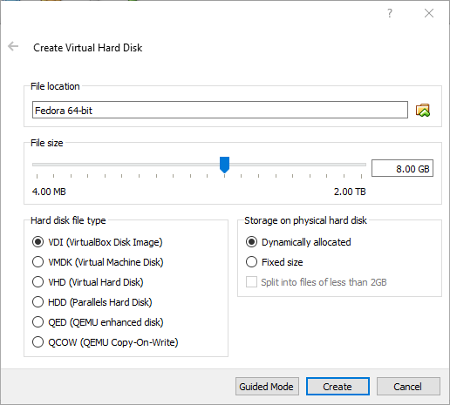

Then we need to adjust settings. First, change the clipboard setting to bidirectional:

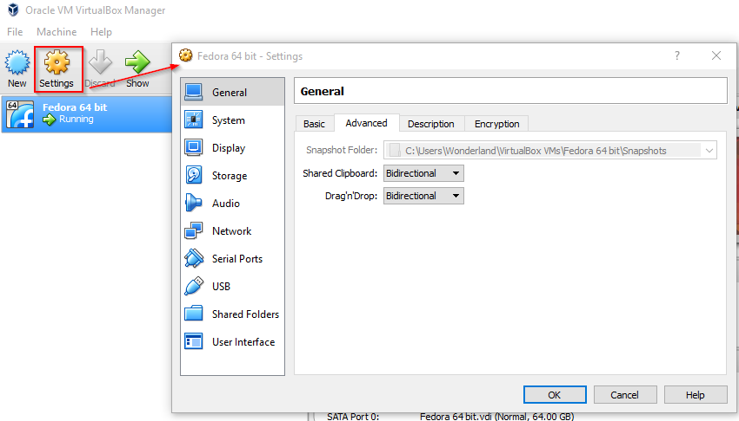

Then create an optical drive for Fedora and “Guest Additions” installations.

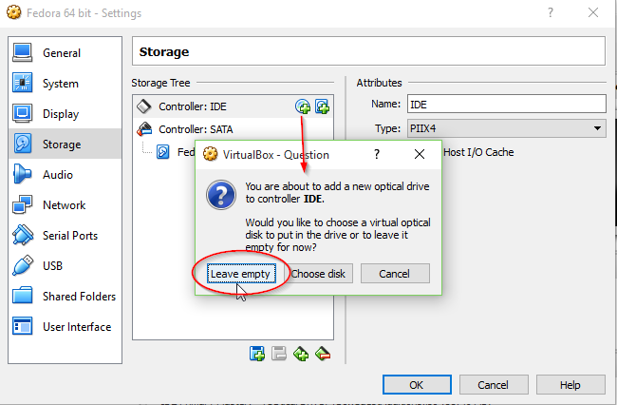

Then for the first time, we need to choose the Fedora ISO file:

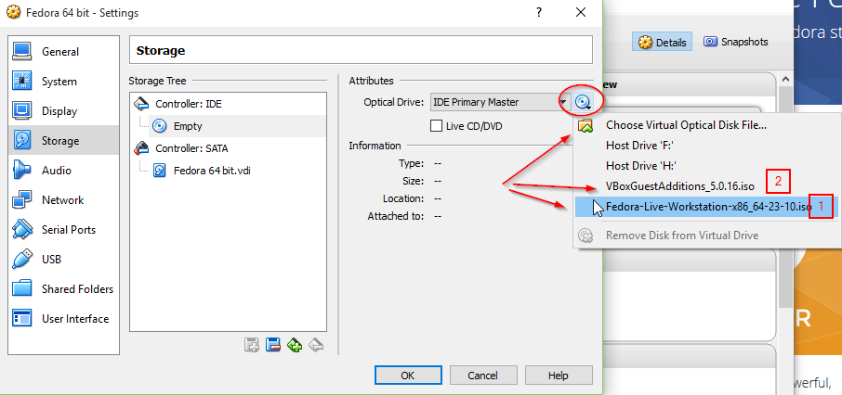

Then create a shared folder between Windows and Fedora:

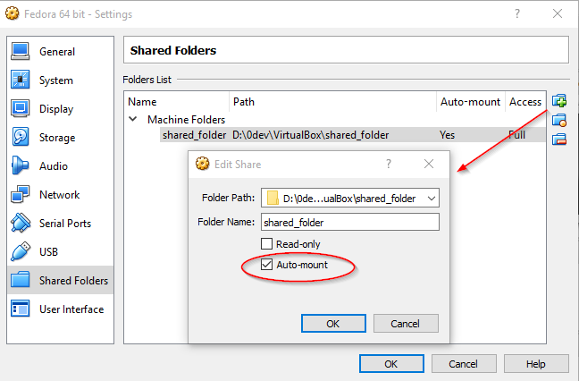

We are ready to start VirtualBox:

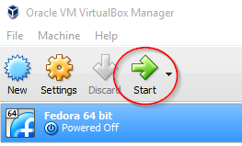

Once we start it, there are two options, one is to use live without installation and the other is to install it on the virtual file system. We choose to install. The rest is just procedures.

After the installation, power down the instance and go back to settings to remove the optical drive and create a new empty one. Then start the instance again.

Now it’s time to create a nonroot user, say pcdev. Then we need to add this user to the sudo group. To add a user to sudoers, run visudo and copy the line from root to a new line and change root to the user. Then we need to install the following 2 packages.

sudo yum install kernel-devel-4.2.3-300.fc23.x86_64

sudo yum install gcc

This installs the kernel package to

/usr/src/kernels/4.2.3-300.fc23.x86_64

Now we ready to install the “Guest Additions” package:

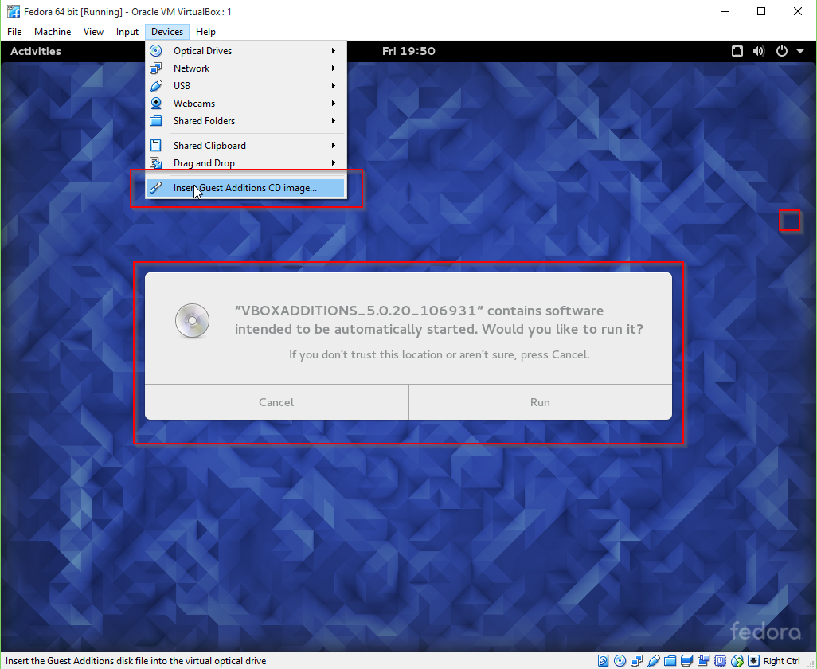

After the run is successful without any error, To fix display size problem:

sudo dnf --showduplicates --allowerasing --releasever=22 downgrade xorg-x11-server-Xorg

This will downgrade the xorg package from 23 to 22. Version 23 has some problems that prevent us from use shared folders, clipboard and screensize adjustment.

Another way to fix these problems is to upgrade:

sudo dnf update

This installs new versions of Xorg and other packages. Now reboot the instance and login again.

sudo dnf install gcc kernel-devel-$(uname -r)

Now install the Guest Additions package and reboot again.

At this point drag-n-drop, clipboard sharing and auto-resize should all work.

For the shared folder permission, we need to add the user to the vboxsf group:

sudo usermod -aG vboxsf $(whoami)

Then restart the instance one more time. You should see your id in the vboxsf group:

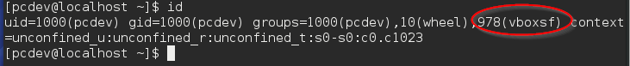

The shared_folder we defined in the settings is mounted under /media/sf_shared_folder, you may check this with mount. To unmount all shares:

sudo umount -f -a -t vboxsf

To mount

sudo mount -t vboxsf shared_folder /mnt/shared

Now the installation is complete.